1. First go to NACE and select the output types

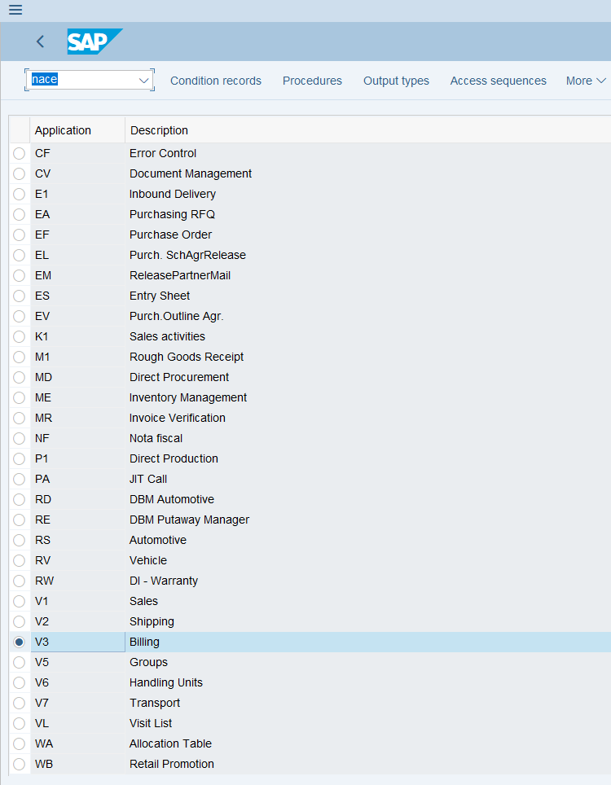

1. Select an output type then processing routine

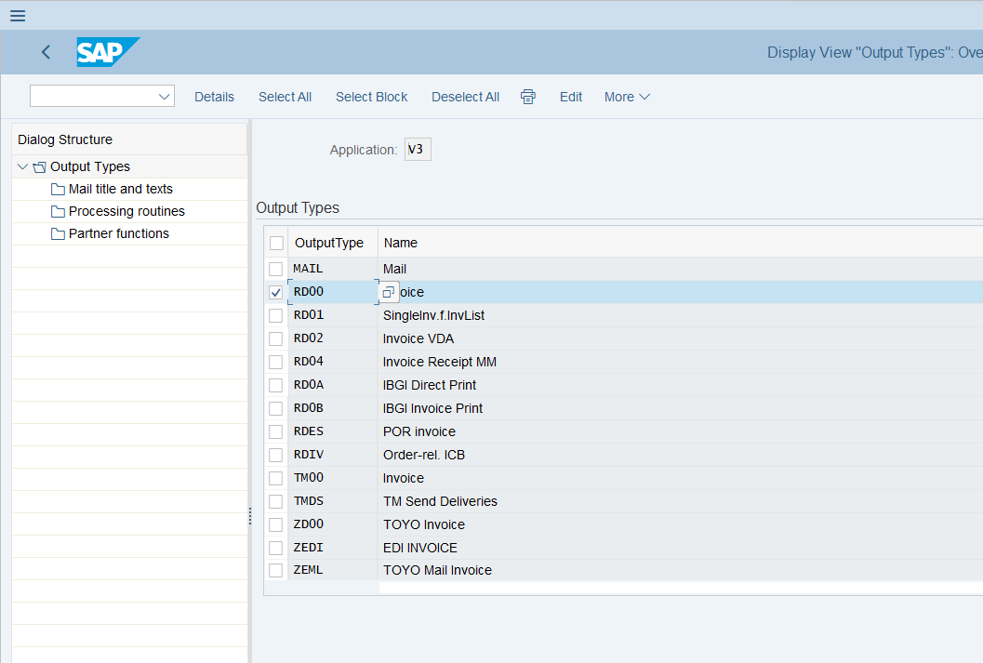

1. Identify the form used

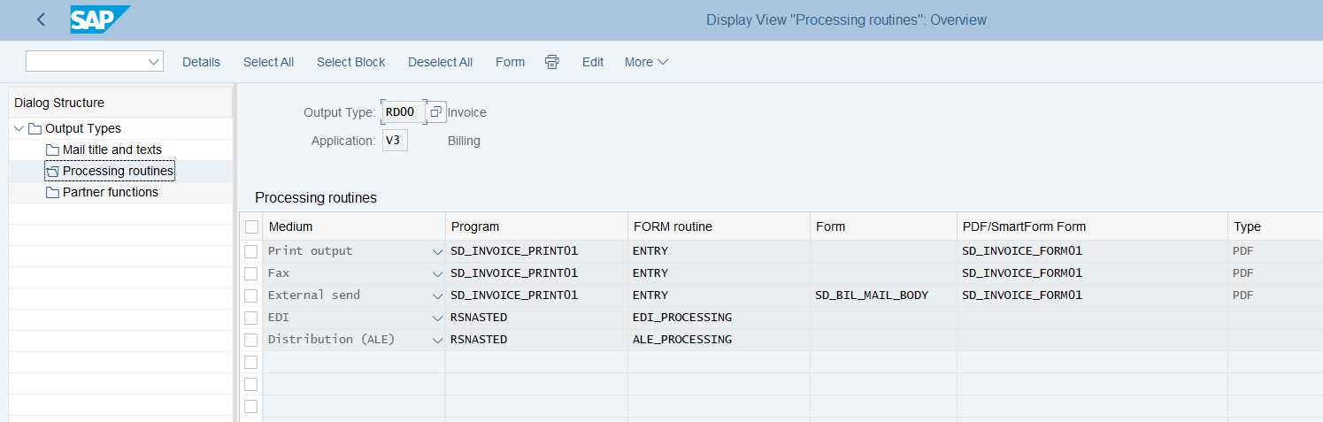

1. Access the form and get the parameter

